**User Manual**

**For Ecommerce System**

**(Amazing)**

**Table of Contents**

|  |  |  |  |
| --- | --- | --- | --- |
| **1** | **OVERVIEW...............................................................................................................** | | **3** |
| **2** | **VISITOR (UNREGISTERED) ....................................................................................** | | **4** |
|  | 2.1 | To Browse the Product Catalogue ............................................................................................ | 5 |
|  | 2.2 | Register for Amazing ............................................................................................................... | 7 |
| **3** | **REGISTERED USER (AUTHENTICATED) ..............................................................** | | **8** |
|  | 3.1 | Adding items to your Shopping Cart ......................................................................................... | 9 |
|  | 3.1.1 | Payment Method .................................................................................................................. | 11 |
|  | 3.2 | Finalising your order ................................................................................................................ | 12 |
| **4** | **MY ORDER LIST ....................................................................................................** | | **13** |
|  | 4.1 | Past Orders ............................................................................................................................. | 14 |
| **5** | **EDIT USER PROFILE.............................................................................................** | | **15** |
| **6** | **CHANGE PASSWORD...........................................................................................** | | **16** |

**1** **OVERVIEW**

This manual provides the step-by-step user guide for the Amazing Ecommerce System (Amazing ).

Amazing website has the following features:

1. Online Catalogue
2. Online Registration function
3. Order Processing
   1. Online Order Status
   2. Past Orders listing for users
   3. Account information

The address to the demo of Amazing website: <https://poochswadge-amazing.herokuapp.com/>

Amazing User Manual

**2** **Visitor (Unregistered)**

A visitor to the site is essentially an unregistered user. A visitor can:

2.1 Browse the Product Catalogue

2.2 Register for Amazing

The Amazing home page is shown below.

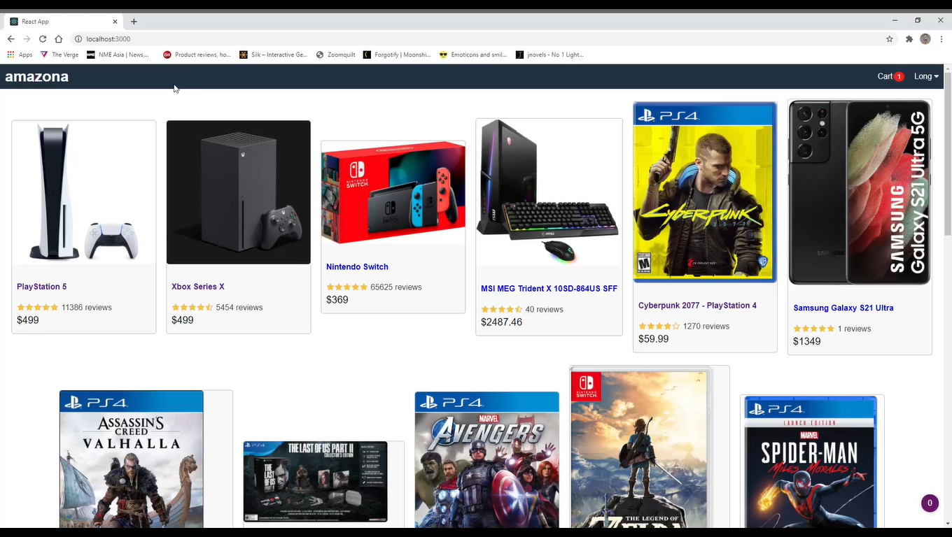

**2.1** **To Browse the Product Catalogue**

When you click on *Product Search* link will allow you to search for Amazing products based on any of the following criteria.

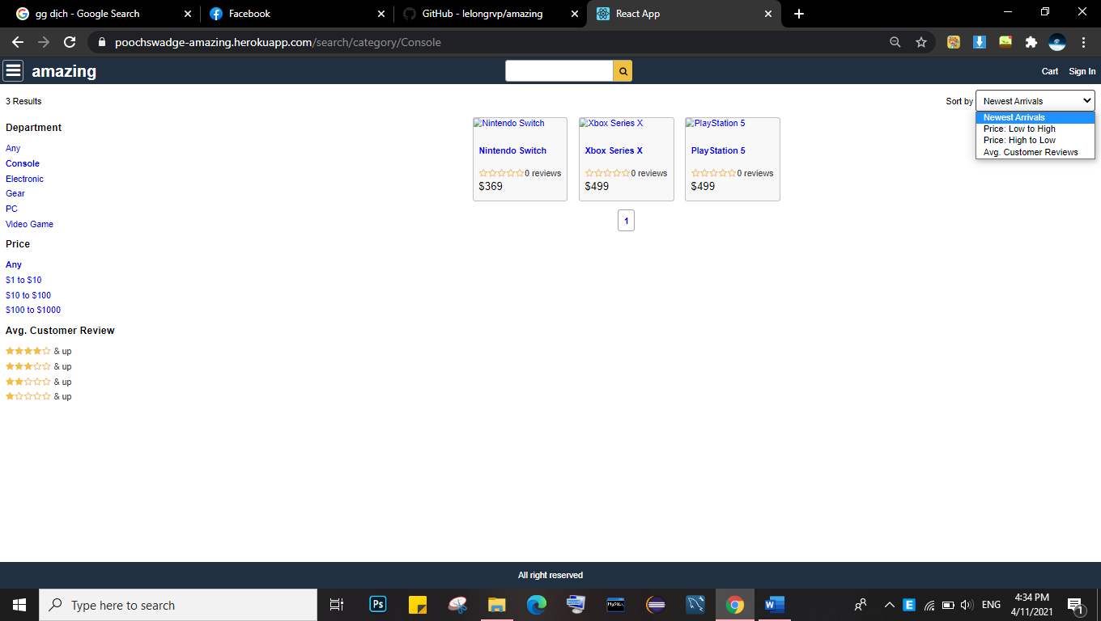

An example of a product information search is shown below.

**NB.** Availability information will be available for registered users only.

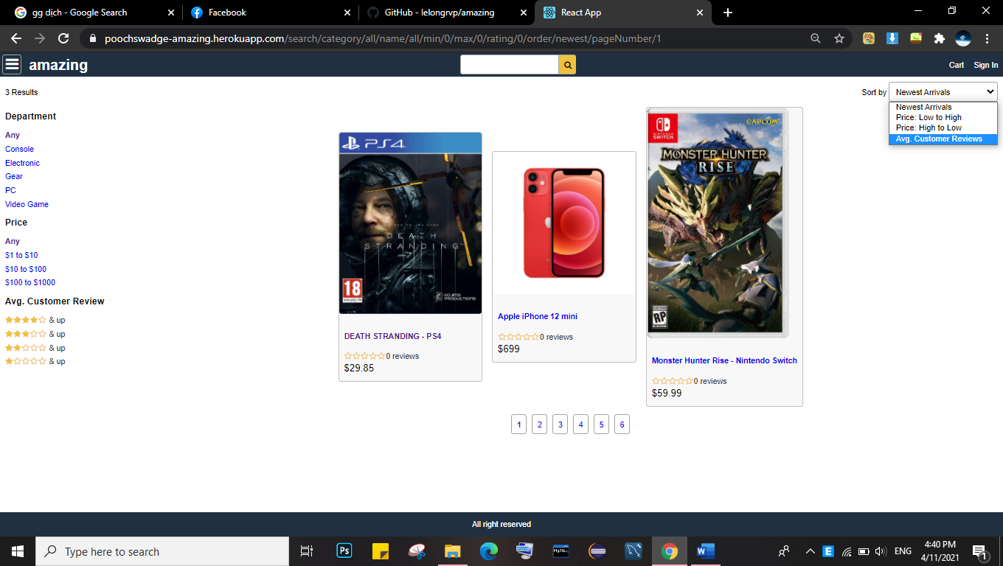

The following additional information about the searched for product may also be available.

* COFA – Certificate of Analysis – An ASP page generated from the Amazing website.
* MSDS – Material Safety Data Sheet – An ASP page generated from the Amazing website. (where

applicable)

* Detailed information on this product – From the Amazing website or from partner website

Products can also be searched for using the categories specified in the left panel as shown below.

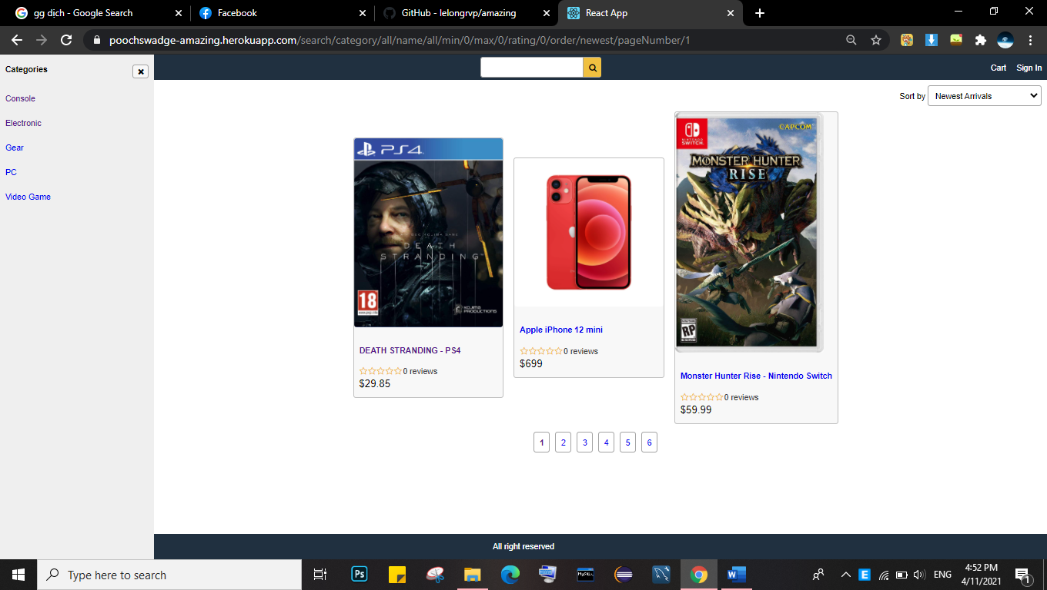

**2.2** **Register for Amazing**

To register for Amazing select the *Sign-in*  option in the top right hand box.

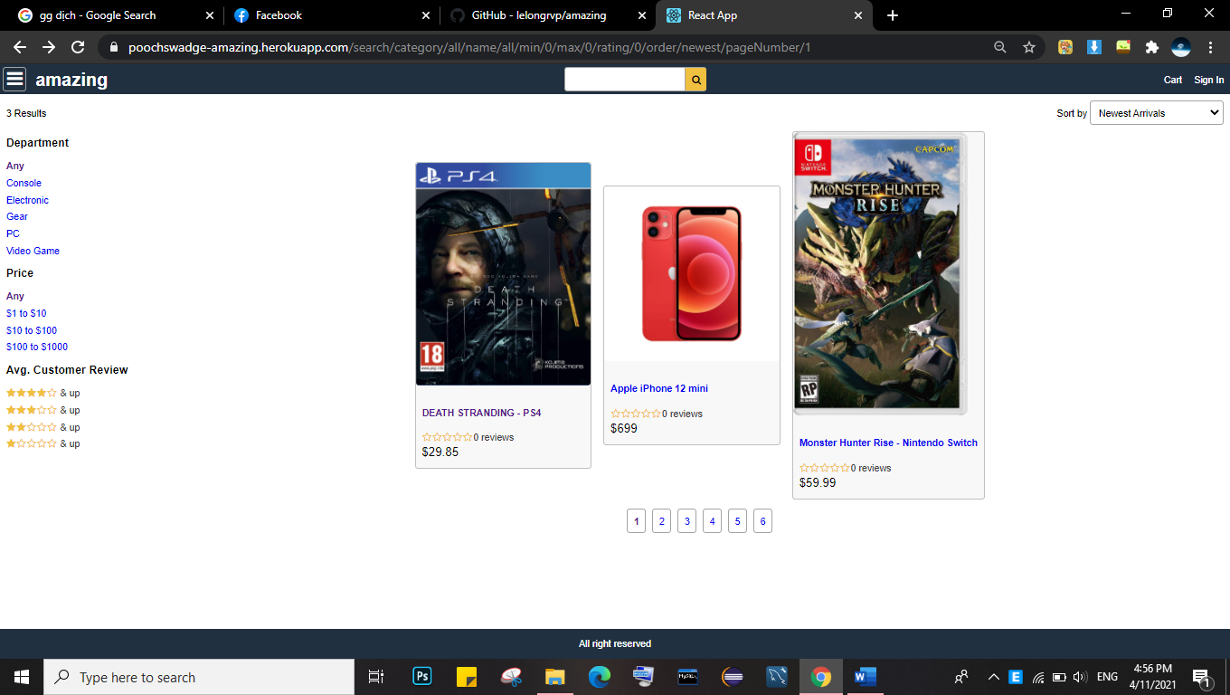

This will take you to the online registration form. Customers are asked to complete this form (all fields marked with a * are mandatory) and click *Ok.*

**NB**. It is recommended that new **users do not use their email address** as their ‘User ID’ as this cancause some issues.

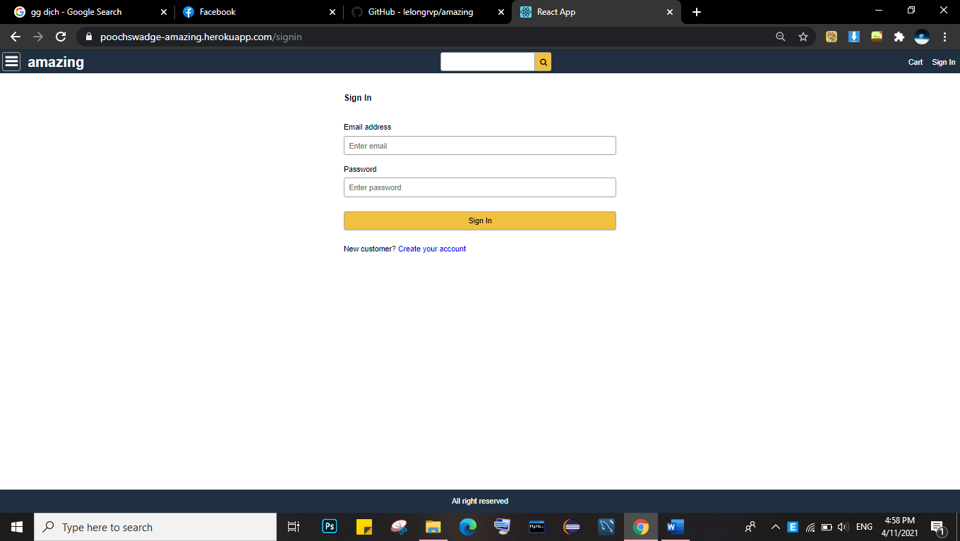

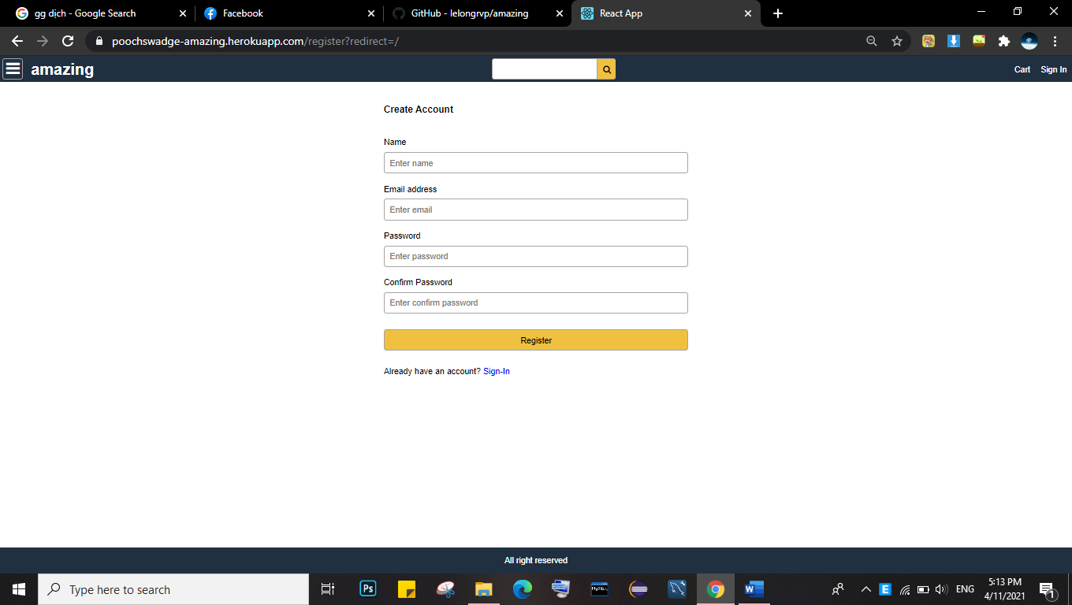

Once the form is received and verified it will be submitted to the Amazing Manager for review and approval.

When the application is approved, you will receive a user name and password from Amazing via email.

**3** **Registered User (Authenticated)**

Once a visitor / company is authenticated, they will receive the username and password in an email.

Using this email, login to the Amazing system.

Once you have been validated by the system, you will see a screen as below:

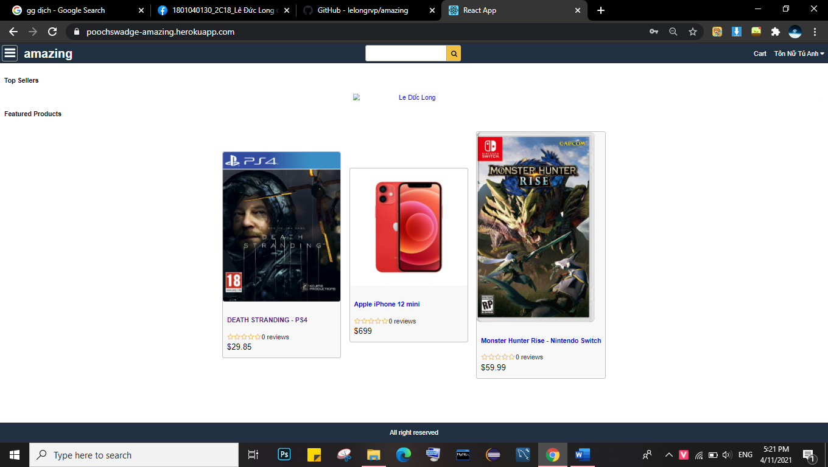

**3.1** **Adding items to your Shopping Cart**

This is the most important feature for customers that allows the creation of online orders.

Selecting this option will bring you to the following screen.

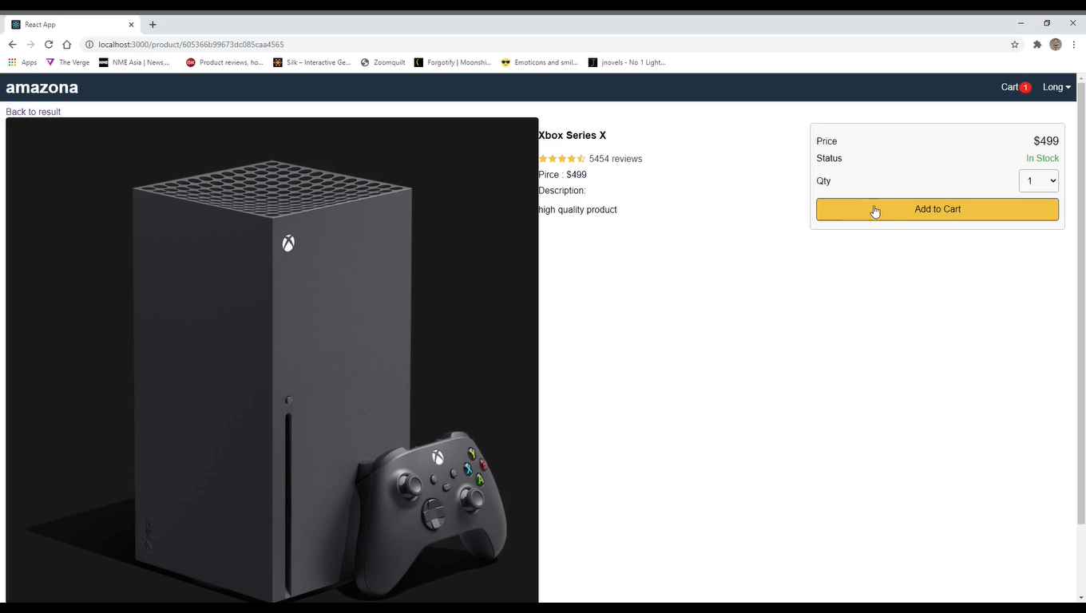

Locate the product you wish to order.

Enter the quantity required and click *Add to Cart.*

You can increase or decrease the amount of product by pressing the up and down arrows or typing the quantity in the box

To check-out click Proceed to Check.

This will give you a pop-up where you can checkout for the product you wish to order.

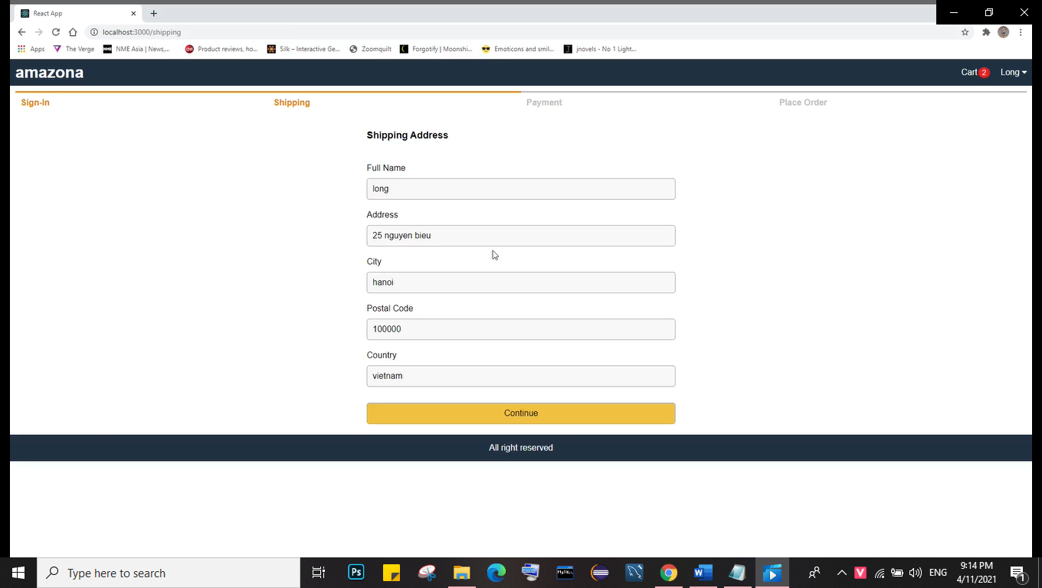

**3.1.1** **Payment method :**

There are two ways to choose for payment :

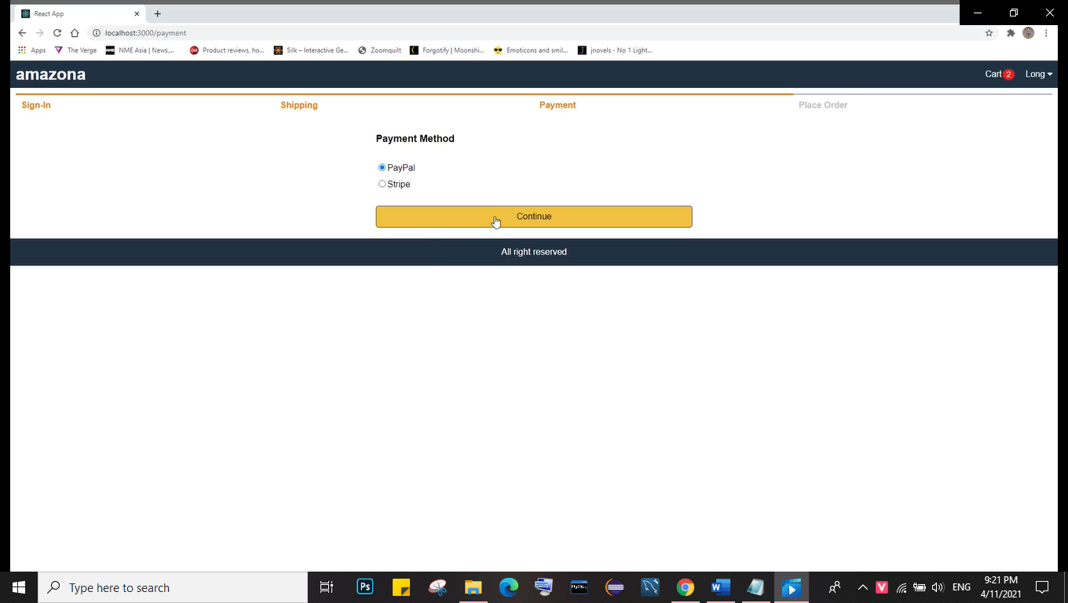

**3.2** **Finalising your order**

To finalise your order you are required to provide the shipping address. Do this by selecting the *Choose* *From Address List* link and either selecting the correct shipping address or entering the delivery address.

Once you are happy with your order please click on the *Place order* button.

You will then be required taken to the order confirmation page. Please select the *Do you agree with our* *Terms & Conditions* checkbox and click on *Submit Order.*

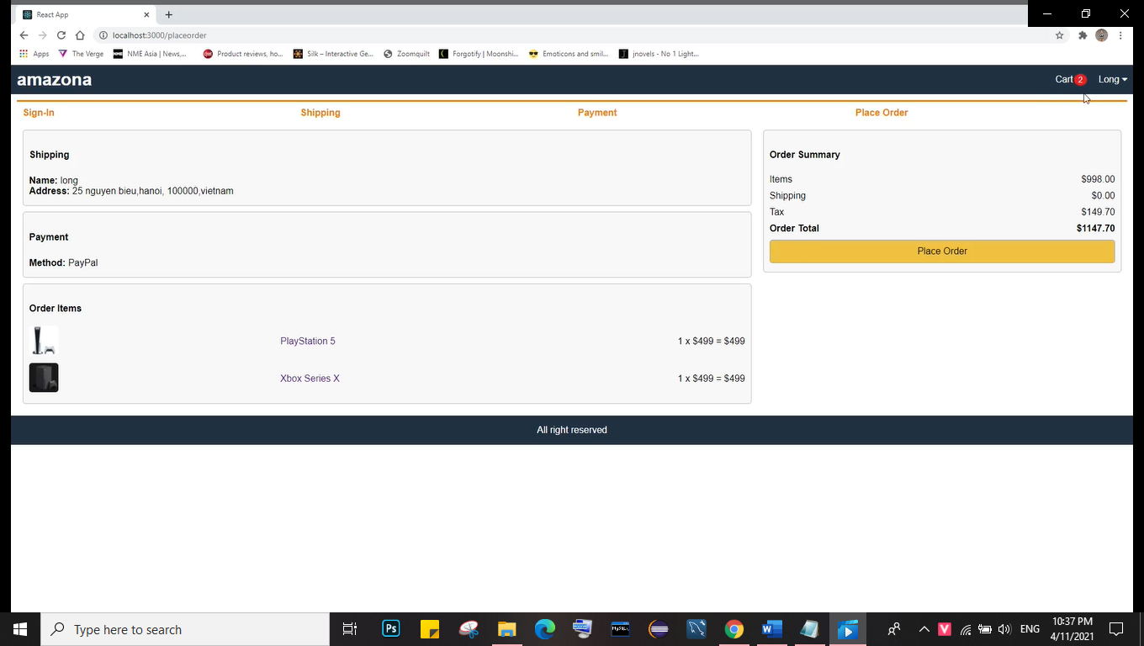

Your order will be sent to Amazing and you will view the *Order Confirmation* screen.

**4** **My Order List**

Selecting the *My Order List* allows users to view the following.

**Past Orders**

This screen shows all the past orders.

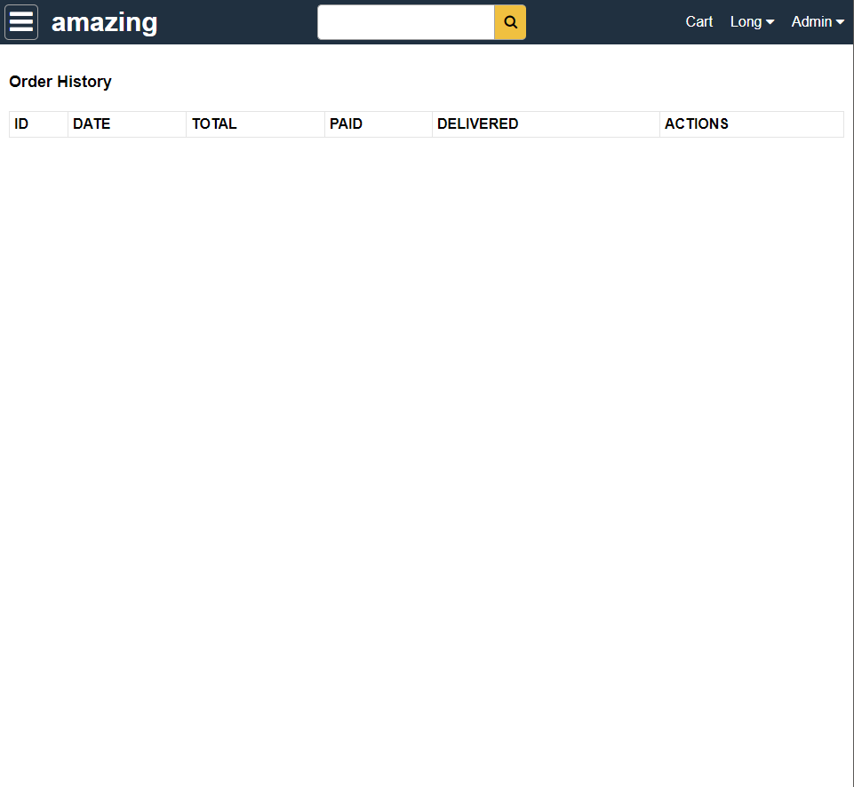

You can filter the past orders using ID, Order Date Range, Time Deliveried or Customer’s reference. You can also view the order by clicking the order number link of any order or invoice details by clicking on the invoice number link.

**5** **Edit User Profile**

You can edit your Profile by selecting the *Edit Profile* button in the box on the left hand side of the screen.

This will display your user details as per below and allow you to make any necessary updates. Once you are happy with your updates, click *Update.*

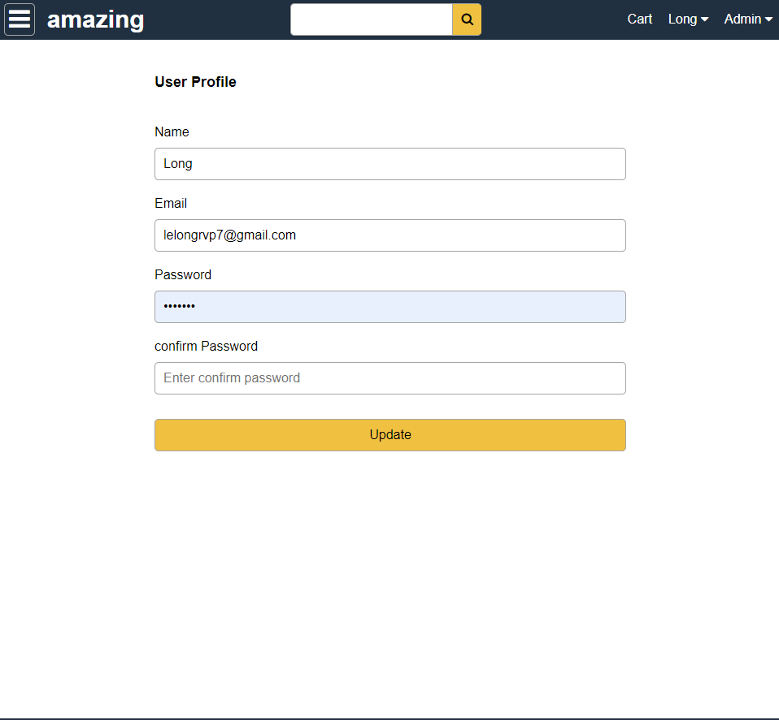

|  |  |  |
| --- | --- | --- |
| **Tips for creating a good password** | **Examples** |  |
|  |  |  |
|  | pag4ks |  |
|  | passwords are |  |
| Use the first letters of a phrase you like, then add a number, punctuation | good for K-State |  |
| mark, or uppercase letter in the middle. Even better is an obscure phrase | pag4mt |  |
| or line from a favorite song, book, movie, or poem. In your phrase, replace | passwords are |  |
| words with numbers or letters (be=B, to=2, too=2, for=4, are=R, see=C, | good for me too |  |
| you=U, why=Y). | pag4m2 |  |
|  | passwords are |  |
|  | good for me too |  |
|  |  |  |
|  | pagb7in |  |
|  | passwords are |  |
| Include numbers. Put one or more numbers in the middle of the password. | good but 7 is not |  |
| Or use three or more numbers at the beginning or end. Or use all numbers. | pagbn200 |  |
|  | passwords are |  |
|  | good but not 200 |  |
|  |  |  |
|  | pagfm? |  |
| Use punctuation marks. A question mark or exclamation mark can add | passwords are |  |
| emphasis to a password phrase you've chosen. You can use any of the | good for me? |  |
| basic punctuation marks on a keyboard: | pag,rtn? |  |
| !@#$%^&*()_+-={}|[]\:";'<>?,./ | passwords are |  |
|  | good, are they not? |  |
|  |  |  |
|  | paGfm2 |  |
| Mix uppercase and lowercase letters. | passwords are |  |
|  | GOOD for me too |  |
|  |  |  |
| Reverse part of a word or phrase to make a nonsense word. Then add a | paS-drow |  |
| number, punctuation mark, or uppercase letter in the middle. |  |
|  |  |
|  |  |  |

**Things you shouldn't use for passwords**

* Don't use building names and codes and all kinds of sports jargon.
* Don't use the first or last names
* Don't use your personal numbers (age, phone number, postal address) or ID codes (date of birth,

driver's license, IC). Those numbers are more public than you think, especially with search engines and the Web.

* Don't include any known information about you, such as parts of your computing ID, name, address, pet names, friends' names, family names, hobbies, or favorites.
* Don't use well-known phrases like "gwtw" (Gone With the Wind) or "2brnot2b" (to be or not to be).
* Don't use obvious number sequences such as "123456" or "8765432".
* Don't use a real word, whether English, foreign, medical, sci-fi, etc.